Newton Abbot Town Council
Smaller Grants Scheme

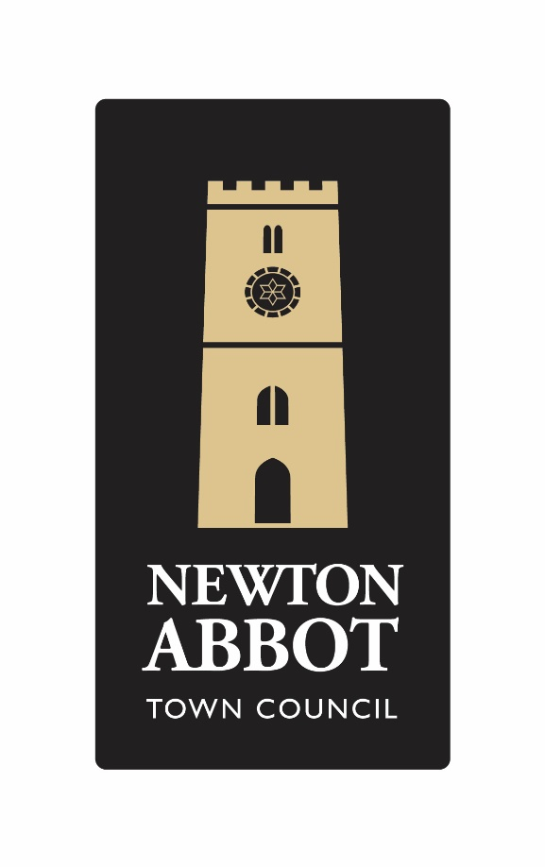
For applications up to £1000.00
Smaller Grants
Criteria:

- Smaller Grant Applications will be considered for any purpose up to the amount of £1000.00

Exclusions to the Grant Scheme:

- Applications that have very few benefits that are for a small number of local residents.
- Grants for and to individuals.
- Applications which indicate a poor ratio of costs to outputs.
- Newton Abbot Town Council will not normally support applications for the payment of salaries.
- Newton Abbot Town Council with not normally consider more than one grant per organisation per year.
- Newton Abbot Town Council will not normally consider grants that principally benefit commercial organisations.
- Newton Abbot Town Council would not normally consider annual ongoing support.

Guidance Notes:
- Your project must directly benefit people living in the Parish of Newton Abbot.

- It is not essential to be a registered charity to apply.

- Newton Abbot Town Council will normally give grants to groups with a bank account in the name of the organisation. If that is not the case, the council will hold any award made and reimburse expenditure on production of receipts within 12 months of the award date

- You must sign a declaration to confirm that you meet all legal requirements for your project. It is your responsibility to check.

- Newton Abbot Town Council utilises taxpayers’ money and must do so transparently. Your attention is drawn to the declaration you sign as part of the application, and how your information may be published in accordance with the requirements of GDPR.

THE APPLICATION FORM

Name of Group Applying
Are you a registered charity? If so, please give your number
Please give estimated dates for

Project start?

Project end?
How much will the project cost?  How much is your grant request?  How will you raise the rest?  Will the project receive match funding –  please provide details  What other grants have been given or refused for the same project? | £  £

Tell us about your group, what does it do?

Does your project/organisation have a social media/website presence?

(Please provide details).

How will you publicise the Newton Abbot Town Council grant?

(Please note it is mandatory as part of the grant award conditions, to supply all press releases concerning the grant to Newton Abbot Town Council for us to share on our social media platforms).

How will the funds be spent? How will it benefit the people of Newton Abbot?

(You can continue on an extra sheet if you wish to)

Sustainability Plan

Tell us how the project will continue once the grant has been spent.

Safeguarding

Where appropriate please provide us with a copy of the project/organisation’s
safeguarding policy with reference to children and vulnerable adults.
Contact name
Contact address
Contact telephone and email address
Bank Account Details Account Name
Sort code Account Number Bank Address

If you do not have a Bank Account for your group, the Council will arrange to hold any grant awarded for you for up to 12 months and will reimburse against receipts.

Does your group meet all legal requirements for this project (e.g., Public Liability, insurance, protection of children and vulnerable adults etc.) | Answer YES or NO  It is YOUR responsibility to check
Signed

Print Name Date
Declaration.

I confirm that to the best of my knowledge and belief, the information in this application form is true and correct. I understand that a request may be made for additional information at any stage of the application process. By completing this form, the signatories hereto agree to this information being retained in accordance with the provisions of the Data Protection Act and for that information to be printed in official council publications and forwarded to other agencies as necessary to facilitate this application for grant aid but for no other purpose.

Signed Date
Please include your constitution and most recent set of accounts if you have these, but it is not essential to receive a grant.

If you need any help in completing this form, please telephone the Deputy Town Clerk on 01626 201120

Please send your completed application form to:

Deputy Town Clerk & RFO
Newton Abbot Town Council
Newton’s Place
43 Wolborough Street
Newton Abbot
TQ12 1JQ
Or via email: sam.scott@newtonabbot-tc.gov.uk

DON’T FORGET TO KEEP A COPY OF WHAT YOU SEND TO US!

What happens next?
You will receive an acknowledgement that your application has been received, which will include information about the date of the meeting at which a decision will be made.

Can we speak at the meeting?
Yes. It is not compulsory, but it is encouraged.
The acknowledgement of your application will include more information about this.

Who do I contact if I have any further questions?

You can speak to the Deputy Town Clerk by email:
sam.scott@newtonabbot-tc.gov.uk or calling by: 01626 201120

Newton Abbot Town Council is open: 8:30am – 4:30pm Monday to Friday

www.newtonabbot-tc.gov.uk

GRANT FEEDBACK FORM

If your grant application is successful Newton Abbot Town Council requires the following questionnaire to be completed and returned at the end of your project or within 12 months of the grant issue date if that is sooner.

Name of project/organisation who received the grant
Contact Details

Name

Position in the Group

Contact Address (Including Post Code)

Telephone

Email
Grant Details

Grant Amount Received

Date Issued

Date Project Started

Date Project Finished or is due to finish

How was the grant spent?
Was the project successful? Give a summary of the project outcome.
What impact has the project had on people involved / the local community?
Was the full grant amount spent? If not, please give details of the amount left, what it will be spent on or whether it is to be returned.
Is there any other feedback you wish to give us?
I confirm that to the best of my knowledge and belief, the information in this application form is true and correct. I understand that a request may be made for additional information at any stage of the application process. By completing this form, the signatories hereto agree to this information being retained in accordance with the provisions of the Data Protection Act and for that information to be printed in official council publications and forwarded to other agencies as necessary to facilitate this application for grant aid but for no other purpose.

Signed Date

