Newton Abbot Town Council

Larger Grants Scheme

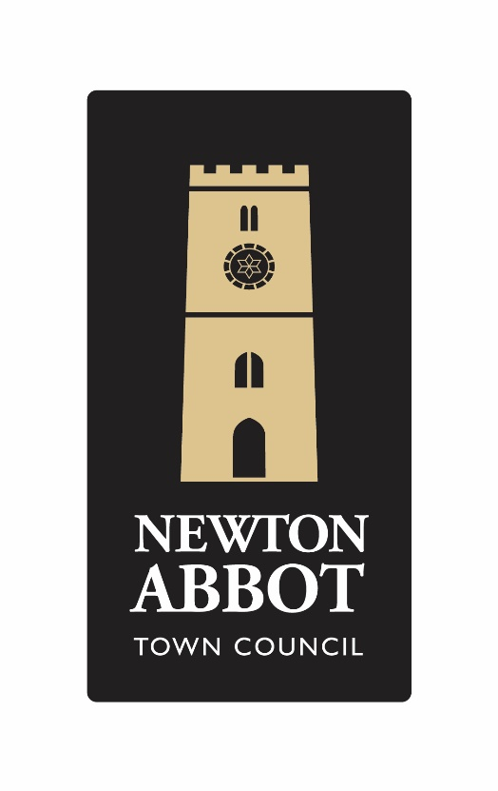

For applications over £1000.00
Larger Grants
Criteria:

- Larger Grant Applications will be considered for amounts over £1000.00, in accordance with the guidance notes.

Exclusions to the Grant Scheme:

- Applications that have very few benefits that are for a small number of local residents.
- Grants for and to individuals.
- Applications which indicate a poor ratio of costs to outputs.
- Newton Abbot Town Council would not normally support applications for the payment of salaries.
- Newton Abbot Town Council would not normally consider more than one grant per organisation per year.
- Newton Abbot Town Council would not normally consider grants that principally benefit commercial organisations.
- Newton Abbot Town Council would not normally consider annual ongoing support.

Guidance Notes:

- Your project must directly benefit people living in the parish of Newton Abbot and this must be demonstrated within your application.

- Grants are usually made in line with the published grant making framework. Newton Abbot Town Council would only go beyond that framework in very exceptional cases.

- Projects that are designed to promote a particular faith or political persuasion will not be funded. However, the council may fund projects organised by such groups if the outcomes have a community benefit. (For example, supporting community musical events that are to take place in a church and which are not designed to promote that faith).

- Newton Abbot Town Council would expect the project to be completed within 12 months of the grant award. You must then provide a written summary of the project stating what has been achieved and how the money has been spent, together with photos and press releases, where appropriate.

- Grant awards are made for the purposes listed on the application form. You cannot change these without the express permission of the council. Any grant which is not used for the purposes applied for must be repaid.

- Applications under the larger grants scheme can only be made by organisations that have a constitution and a bank account.

- Newton Abbot Town Council utilises taxpayers’ money and must do so transparently. Your attention is drawn to the declaration you sign as part of the application, and how your information may be published in accordance with the requirements of GDPR.

- The decision of Newton Abbot Town Council on any application is final. If you think your application has not been considered fairly you can complain using the council’s official complaints process. Details are available from the Town Clerk.

- Should you have any questions about this process, please ask us for help.

Some Useful Questions to Ask Yourself
The following is for you to practice before you write your application, and you do not have to send this sheet to us (Unless you want to)

WHAT do we expect our project is going to achieve?

WHAT is it going to cost?

WHAT will we contribute to the project? (This might be volunteer time rather than tangible cash).

WHY is it needed?

WHEN will it start and finish?

HOW will we do it, and HOW will we know it has been a success?

WHERE will it take place?

WHO is going to benefit from our hard work?

WHO else will help pay for the project?

THE APPLICATION FORM

Name of Group Applying
Contact Details for this Application

Name

Position in the Group

Contact Address (Including Post Code)

Telephone

Email
Are you a registered charity?

If so, please give your number

It is not essential to be a registered charity to get a grant under this scheme
Tell us about your group, what does it do?

Does your project/organisation have a social media/website presence?

(Please provide details).

How will you publicise the Newton Abbot Town Council grant?

(Please note it is mandatory as part of the grant award conditions, to supply all press releases concerning the grant to Newton Abbot Town Council for us to share on our social media platforms).

How will you spend the funds? How will it benefit the people of Newton Abbot?

(Please see the useful questions page for suggestions about information to include).

(You can continue on a separate sheet if needed)

Sustainability Plan

Tell us how the project will continue once the grant has been spent.

Safeguarding

Where appropriate please provide us with a copy of the project/organisation’s
safeguarding policy with reference to children and vulnerable adults.
Please give estimated dates for Project start?  Project end? | Start  End
How much will the project cost? How much is your grant request? How will you raise the rest?  Will the project receive match funding –  please provide details  What other grants have been given or refused for the same project? | £  £

Please provide projected income and expenditure with a breakdown of the costs involved in your project.

Please provide the following information from your latest accounts
Total income | £
Total expenditure | £
Annual profit or loss | £
Total unrestricted funds in your bank | £
(This is money that is not earmarked for a special purpose, and which you are free to spend as you choose).
YOU MUST SEND US A COPY OF YOUR LAST ACCOUNTS AND YOUR CONSTITUTION
Bank Account Details  Account Name Sort Code Account Number  Bank Name Bank Address  How many signatories are required to authorise payments? | 1 / 2 / 3/ MORE?

Does your group meet all legal requirements for this project (e.g., Public Liability, insurance, Protection of Children and Vulnerable Adults etc.) | Answer YES or NO  It is YOUR responsibility to check
Second Contact for this Application | This is someone in your organisation who we can contact if we want to check the information given
Name
Position in the Group
Contact Address (Including Post Code)
Telephone
Email
Declaration.

I confirm that to the best of my knowledge and belief, the information in this application form is true and correct. I understand that a request may be made for additional information at any stage of the application process. By completing this form, the signatories hereto agree to this information being retained in accordance with the provisions of the Data Protection Act and for that information to be printed in official council publications and forwarded to other agencies as necessary to facilitate this application for grant aid but for no other purpose.

Signed Date

If you need any help in completing this form, please telephone the Deputy Town Clerk & RFO on 01626 201120
or via email: sam.scott@newtonabbot-tc.gov.uk

Please send your completed application form to:

Deputy Town Clerk & RFO
Newton Abbot Town Council
Newton’s Place
43 Wolborough Street
Newton Abbot
TQ12 1JQ

DON’T FORGET TO KEEP A COPY OF WHAT YOU SEND TO US!

What happens next?
You will receive an acknowledgement that your application has been received, which will include information about the date of the meeting at which a decision will be made.

Can we speak at the meeting?
Yes. It is not compulsory, but it is encouraged.
The acknowledgement of your application will include more information about this.

Who do I contact if I have any further questions?

You can speak to the Deputy Town Clerk by email:
sam.scott@newtonabbot-tc.gov.uk or calling by: 01626 201120

Newton Abbot Town Council is open:

8:30am – 4:30pm Monday to Friday

www.newtonabbot-tc.gov.uk

GRANT FEEDBACK FORM

If your Grant Application is successful Newton Abbot Town Council requires the following questionnaire to be completed and returned at the end of your project or within 12 months of the grant issue date if that is sooner.

Name of Project/Organisation who received the Grant
Contact Details

Name

Position in the Group

Contact Address (Including Post Code)

Telephone

Email
Grant Details

Grant Amount Received

Date Issued

Date Project Started

Date Project Finished or is due to finish

How was the grant spent?
Was the project successful? Give a summary of the project outcome.
What impact has the project had on people involved / the local community?
Was the full grant amount spent? If not, please give details of the amount remaining, what it will be spent on or whether it is to be returned.
Is there any other feedback you wish to give us?
I confirm that to the best of my knowledge and belief, the information in this application form is true and correct. I understand that a request may be made for additional information at any stage of the application process. By completing this form, the signatories hereto agree to this information being retained in accordance with the provisions of the Data Protection Act and for that information to be printed in official council publications and forwarded to other agencies as necessary to facilitate this application for grant aid but for no other purpose.

Signed Date

